COMPLETE MASTER REPORT
ARDUINO RC CAR PROJECT
Normal USB Control | Bluetooth HC-05 Control | All Codes | All Problems Solved | From Scratch to Working

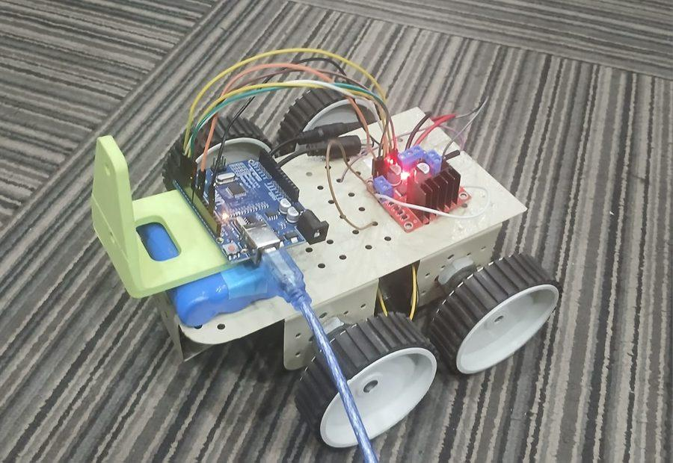
Your completed Arduino RC Car — Arduino UNO + L298N + HC-05 Bluetooth + 4 DC Motors

What This Report Contains
Normal Arduino Code (USB) + Bluetooth Arduino Code (HC-05) + Python USB Script + Python BT Script
Complete Wiring + All 20+ Problems Documented + Build Photos + Future Upgrades

Section 1 — Project Overview
This is the complete master report for your Arduino RC Car project. It combines everything from the original build, the Bluetooth upgrade, all code files, all problems encountered during the actual build session, and their solutions. It covers both control modes separately.

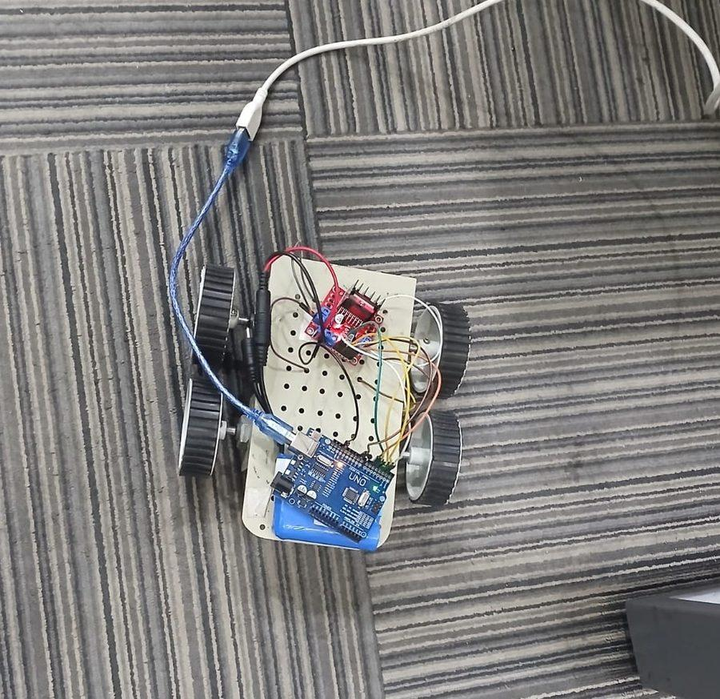  Fig 1 — Early prototype build | 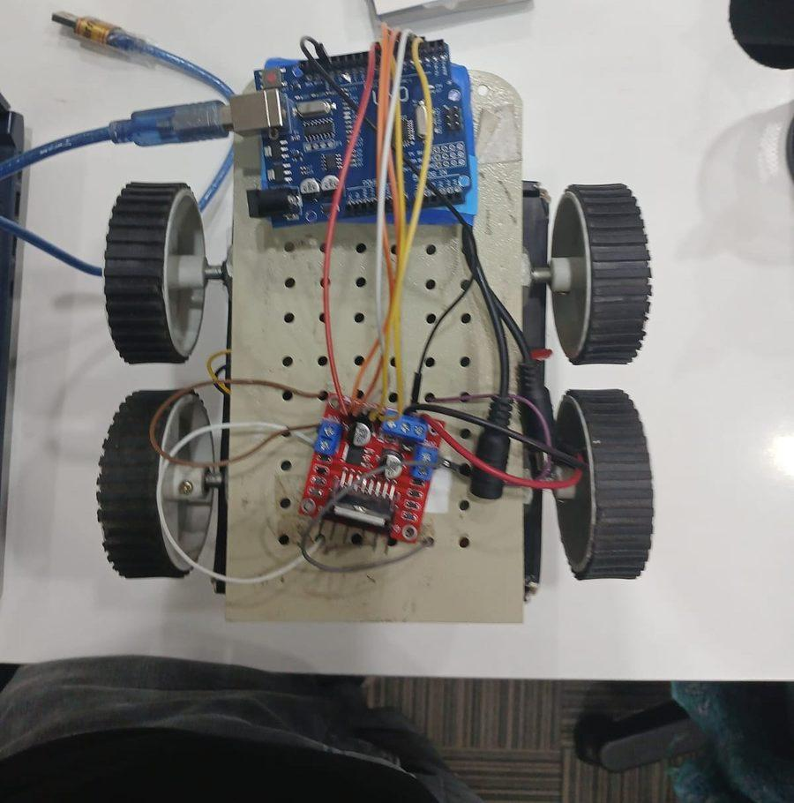  Fig 2 — Final version with all components

1.1 Two Control Modes
Mode | Hardware Used | Control Method | Arduino Code File | Python Script
Normal (USB) | Arduino + L298N | Laptop keyboard via USB cable | rc_car_normal.ino | rc_car_usb.py
Bluetooth (HC-05) | Arduino + L298N + HC-05 | Laptop BT OR Android phone | rc_car_bluetooth.ino | rc_car_bt.py

1.2 System Architecture
Layer | Component | Normal Mode | Bluetooth Mode
Brain | Arduino UNO R3 | Controls via USB Serial | Controls via USB + SoftwareSerial
Muscle | L298N Motor Driver | Same in both modes | Same in both modes
BT Radio | HC-05 Module | Not used | Pins 10/11 (SoftwareSerial)
Power Brain | USB from Laptop | Powers Arduino | Powers Arduino (keep plugged)
Power Motors | Battery 6V-9V | Powers motors | Powers motors
Laptop Control | Python script | COM5 (USB port) | COM7 (BT port)
Phone Control | Android app | Not available | Serial Bluetooth Terminal app

Section 2 — Components List
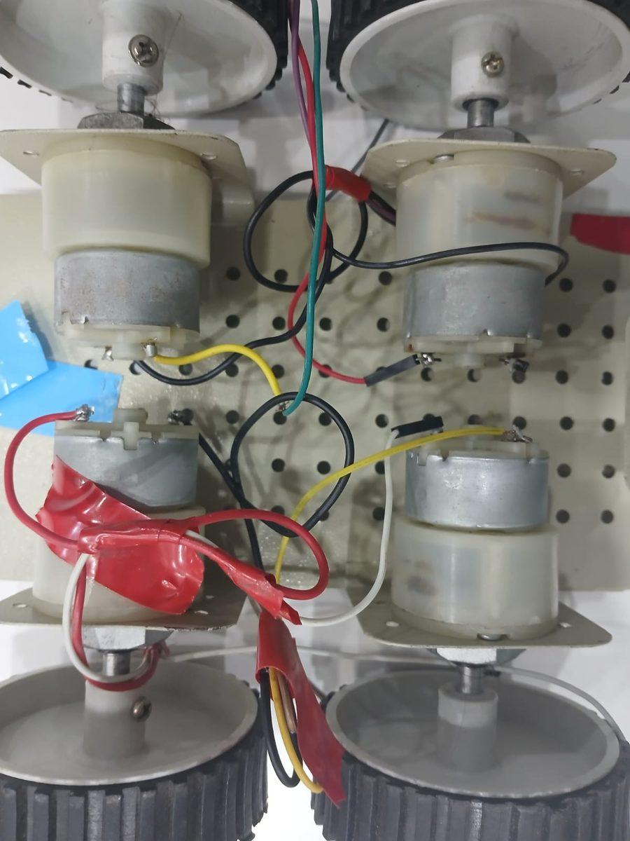  Fig 3 — TT DC gear motors close-up | 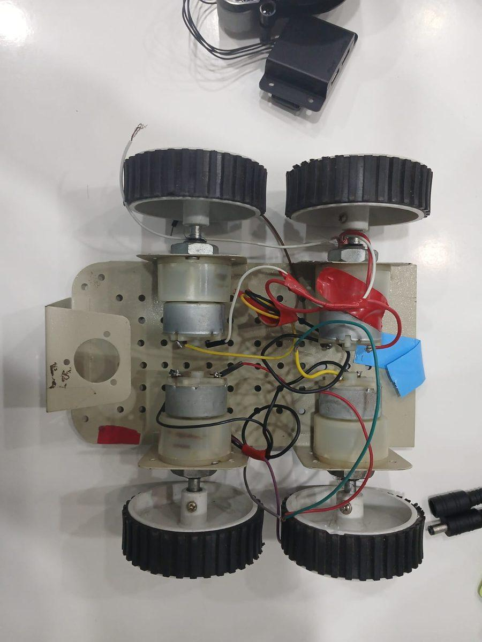  Fig 4 — Underside showing 4 motors

2.1 Base Components (Both Modes)
Component | Qty | Purpose | Analogy
Arduino UNO R3 | 1 | Brain — runs all code, reads commands | Human brain
L298N Motor Driver | 1 | H-bridge — controls motor direction and speed | Strong worker
TT DC Gear Motor | 4 | Spins the wheels (3V-6V, yellow) | Legs and feet
65mm Rubber Wheel | 4 | Attaches to motor shaft, provides grip | Shoes
4WD Robot Chassis | 1 | Frame that holds all components | Skeleton
Battery Pack 6V-9V | 1 | Powers motors via L298N | Fuel
USB Type-B Cable | 1 | Powers Arduino AND carries commands | Telephone line
Jumper Wires (M-M) | 20+ | All electrical connections | Roads

2.2 Additional Components for Bluetooth Mode
Component | Qty | Cost India | Purpose
HC-05 Bluetooth Module | 1 | Rs 150-250 | Receives BT from phone, sends to Arduino
Jumper Wires (M-F) | 4 | Rs 10-20 | Connect HC-05 to Arduino — 4 wires only
Android Phone | 1 | You have it | Runs the Bluetooth controller app

Section 3 — Complete Wiring for Both Modes
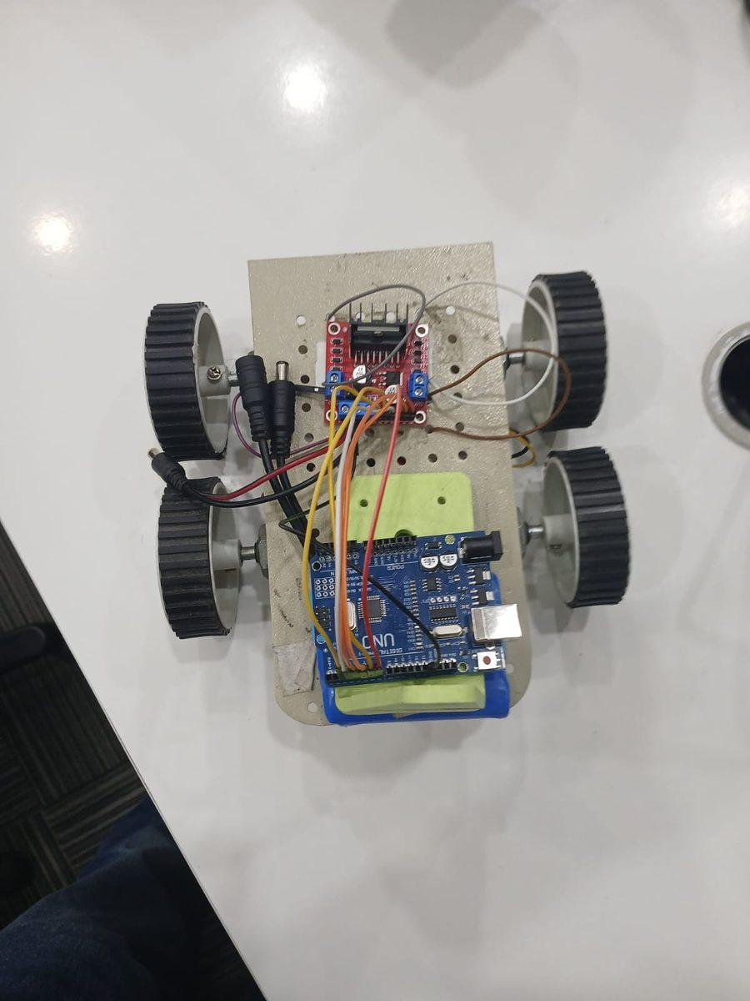  Fig 5 — Top view: Arduino + L298N mounted | 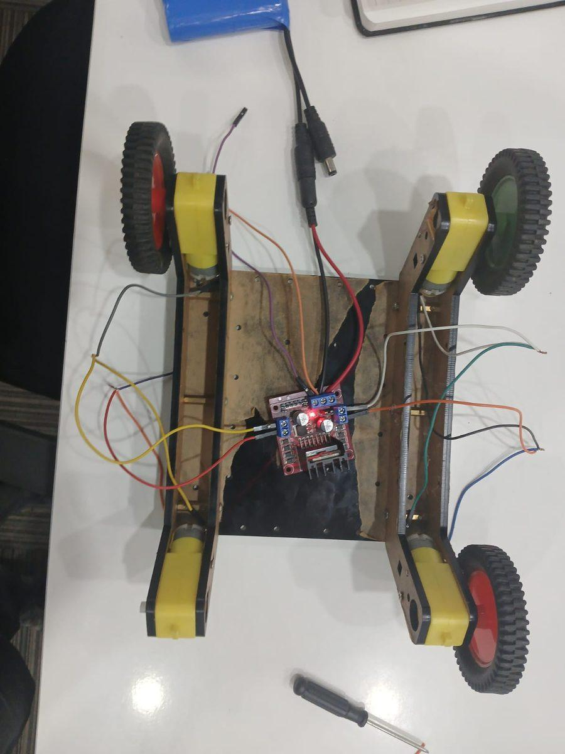  Fig 6 — Wooden chassis variant with all wires

3.1 Normal Mode Wiring (Arduino + L298N Only)
From | To | Wire Color | Purpose
Arduino Pin 2 | L298N IN1 | Blue | Left motor direction 1
Arduino Pin 3 | L298N IN2 | Blue | Left motor direction 2
Arduino Pin 4 | L298N IN3 | Blue | Right motor direction 1
Arduino Pin 5 | L298N IN4 | Blue | Right motor direction 2
Arduino Pin 6 (PWM) | L298N ENA | Blue dashed | Left motor speed control
Arduino Pin 9 (PWM) | L298N ENB | Blue dashed | Right motor speed control
Arduino GND | L298N GND | BLACK THICK | MOST CRITICAL — without this car will NOT move
Battery + | L298N VIN | Red thick | Motor power supply 6V-9V
Battery - | L298N GND | Black thick | Battery ground
L298N OUT1+OUT2 | Left motors x2 | Green | Both left motors in parallel
L298N OUT3+OUT4 | Right motors x2 | Yellow | Both right motors in parallel
Laptop USB | Arduino USB port | Blue cable | Powers Arduino + carries commands

3.2 Bluetooth Mode — 4 Extra Wires for HC-05
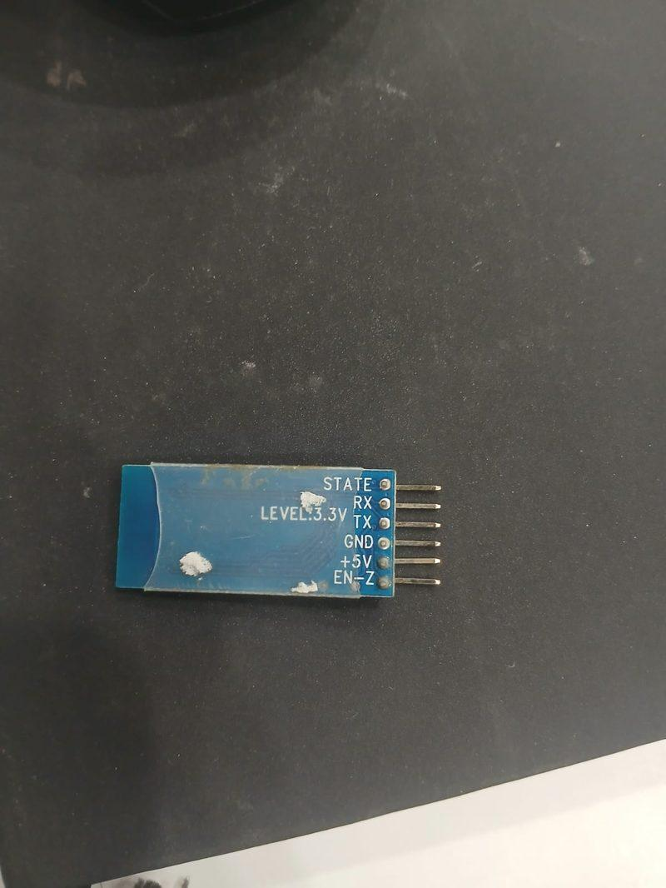  Fig 7 — HC-05 back: pin labels visible (STATE RX TX GND +5V EN-Z) | 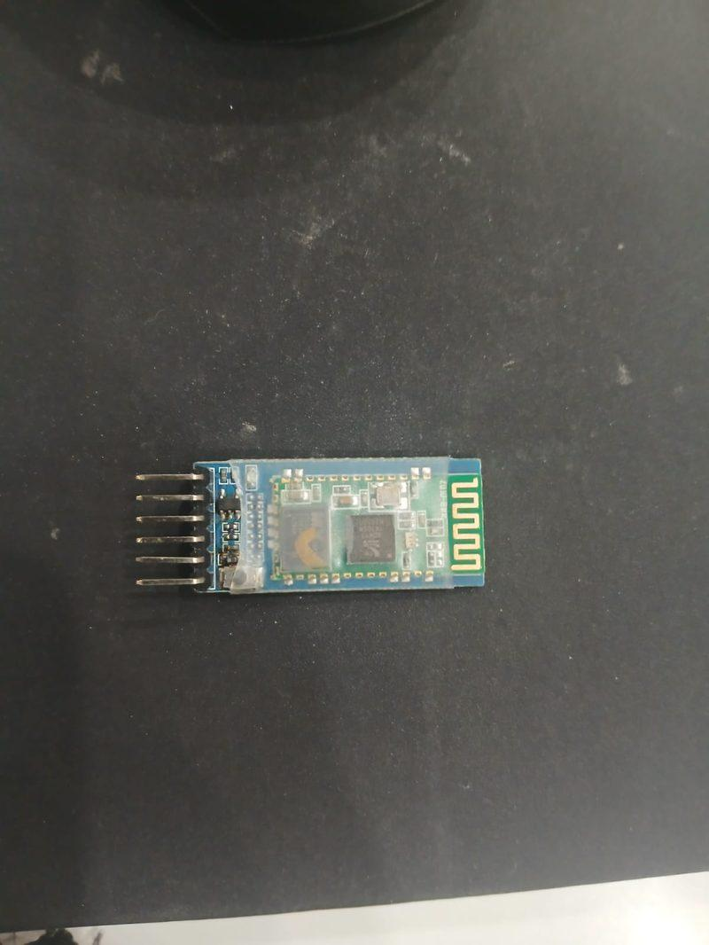  Fig 8 — HC-05 front: Bluetooth chip and antenna

HC-05 Pin | Connect To | Wire Color | Purpose
+5V | Arduino 5V pin | Red | Powers the Bluetooth module
GND | Arduino GND pin | Black | Common ground (MANDATORY)
TX | Arduino Pin 10 | Green | HC-05 sends data to Arduino (no resistor needed)
RX | Arduino Pin 11 | Yellow | Arduino sends data to HC-05 (direct is OK for testing)

The Most Critical Wire in the Entire Build
Arduino GND → L298N GND (black wire)
Without this wire, the L298N cannot understand any signal from Arduino.
Car will be completely dead even if all other wires are correct.
This was the most common problem encountered during your actual build session.
Always check this wire FIRST whenever the car does not respond.

HC-05 LED Meaning — Always Check This First
Fast blink (every 0.5 sec) = Powered on, waiting to pair or connect. Ready.
Slow blink (every 2 sec) = Paired to a device but not actively connected.
Very slow / solid = Actively connected to phone or Python opened the port.
No LED at all = Module has no power. Check +5V red wire and GND black wire.
This was a key diagnostic during your build — always look at LED first.

Section 4 — Commands, Keys and Movements

4.1 All Commands Reference
Key | Arrow Key | Movement | Left Motor | Right Motor
F | UP Arrow | Forward | FORWARD | FORWARD
B | DOWN Arrow | Backward | BACKWARD | BACKWARD
L | LEFT Arrow | Turn Left | STOP | FORWARD
R | RIGHT Arrow | Turn Right | FORWARD | STOP
S | SPACE | Stop | STOP | STOP
G | (none) | Rotate Left in place | BACKWARD | FORWARD
I | (none) | Rotate Right in place | FORWARD | BACKWARD
1 | (none) | Speed Slow | analogWrite 60 | analogWrite 60
2 | (none) | Speed Medium | analogWrite 130 | analogWrite 130
3 | (none) | Speed Fast | analogWrite 190 | analogWrite 200

4.2 How Arrow Keys Work in Python
The Python script checks keyboard state 12 times per second (every 80ms). When you hold an arrow key, it continuously sends that command. The moment you release, the else branch sends S (Stop). This gives real-time hold-to-move, release-to-stop control over both USB and Bluetooth.
Key Behaviour | USB Mode | Bluetooth Mode
Hold UP arrow | Sends F to Arduino via COM5 USB | Sends F to Arduino via COM7 BT
Release UP arrow | Sends S (stop) immediately | Sends S (stop) immediately
Hold LEFT arrow | Sends L (turn left) | Sends L (turn left)
Press 1 key | Changes speed to Slow (60) | Changes speed to Slow (60)
Press ESC | Sends S, closes port, exits script | Sends S, closes BT port, exits

Section 5 — Arduino Code: Normal USB Mode
Use this code when you are controlling via USB cable and laptop only. No Bluetooth module connected. Upload via Arduino IDE. This is the simpler version.

How to Upload
Arduino IDE -> Tools -> Board -> Arduino UNO
Arduino IDE -> Tools -> Port -> your COM port (e.g. COM5)
Click the Upload button (right arrow icon)
Wait for Done uploading message
Open Serial Monitor at 9600 baud to verify RC CAR NORMAL MODE appears

rc_car_normal.ino | Arduino C++ | Upload to Arduino UNO | No BT module needed
// ================================================================
// RC CAR — NORMAL LAPTOP USB CONTROL CODE
// Hardware : Arduino UNO R3 + L298N Motor Driver
// Control : Laptop USB Serial (Arduino IDE / Python / Processing)
// Commands : F=Forward B=Backward L=TurnLeft R=TurnRight
// S=Stop G=RotateLeft I=RotateRight
// 1=Slow 2=Medium 3=Fast
// ================================================================

const int IN1=2, IN2=3, IN3=4, IN4=5, ENA=6, ENB=9;

// Tune to fix drift: car drifts RIGHT → lower L_SPEED by 5
int L_SPEED=190, R_SPEED=200, TURN_SPEED=160;

void setup(){
pinMode(IN1,OUTPUT); pinMode(IN2,OUTPUT);
pinMode(IN3,OUTPUT); pinMode(IN4,OUTPUT);
pinMode(ENA,OUTPUT); pinMode(ENB,OUTPUT);
Serial.begin(9600);
Serial.println("=== RC CAR NORMAL MODE ===");
Serial.println("F=Fwd B=Bwd L=Left R=Right");
Serial.println("G=RotL I=RotR S=Stop");
Serial.println("1=Slow 2=Med 3=Fast");
stopCar();
}

void loop(){
if(Serial.available()>0){
char cmd=Serial.read();
switch(cmd){
case 'F': case 'f': moveForward(); break;
case 'B': case 'b': moveBackward(); break;
case 'L': case 'l': turnLeft(); break;
case 'R': case 'r': turnRight(); break;
case 'S': case 's': stopCar(); break;
case 'G': case 'g': rotateLeft(); break;
case 'I': case 'i': rotateRight(); break;
case '1': L_SPEED=60; R_SPEED=60; Serial.println("SLOW"); break;
case '2': L_SPEED=130; R_SPEED=130; Serial.println("MEDIUM"); break;
case '3': L_SPEED=190; R_SPEED=200; Serial.println("FAST"); break;
}
}
}

void moveForward(){
digitalWrite(IN1,HIGH); digitalWrite(IN2,LOW);
digitalWrite(IN3,HIGH); digitalWrite(IN4,LOW);
analogWrite(ENA,L_SPEED); analogWrite(ENB,R_SPEED);
Serial.println(">> FORWARD");
}
void moveBackward(){
digitalWrite(IN1,LOW); digitalWrite(IN2,HIGH);
digitalWrite(IN3,LOW); digitalWrite(IN4,HIGH);
analogWrite(ENA,L_SPEED); analogWrite(ENB,R_SPEED);
Serial.println(">> BACKWARD");
}
void turnLeft(){
digitalWrite(IN1,LOW); digitalWrite(IN2,LOW);
digitalWrite(IN3,HIGH); digitalWrite(IN4,LOW);
analogWrite(ENA,0); analogWrite(ENB,TURN_SPEED);
Serial.println(">> TURN LEFT");
}
void turnRight(){
digitalWrite(IN1,HIGH); digitalWrite(IN2,LOW);
digitalWrite(IN3,LOW); digitalWrite(IN4,LOW);
analogWrite(ENA,TURN_SPEED); analogWrite(ENB,0);
Serial.println(">> TURN RIGHT");
}
void stopCar(){
digitalWrite(IN1,LOW); digitalWrite(IN2,LOW);
digitalWrite(IN3,LOW); digitalWrite(IN4,LOW);
analogWrite(ENA,0); analogWrite(ENB,0);
Serial.println(">> STOP");
}
void rotateLeft(){
digitalWrite(IN1,LOW); digitalWrite(IN2,HIGH);
digitalWrite(IN3,HIGH); digitalWrite(IN4,LOW);
analogWrite(ENA,TURN_SPEED); analogWrite(ENB,TURN_SPEED);
Serial.println(">> ROTATE LEFT");
}
void rotateRight(){
digitalWrite(IN1,HIGH); digitalWrite(IN2,LOW);
digitalWrite(IN3,LOW); digitalWrite(IN4,HIGH);
analogWrite(ENA,TURN_SPEED); analogWrite(ENB,TURN_SPEED);
Serial.println(">> ROTATE RIGHT");
}

Section 6 — Arduino Code: Bluetooth + USB Dual Mode
Use this code when HC-05 is connected. This code handles BOTH USB laptop control AND Bluetooth phone control simultaneously. The loop checks both serial channels every tick.

Key Difference from Normal Code
Adds: #include <SoftwareSerial.h> at the top
Adds: SoftwareSerial bluetooth(10, 11) — creates BT channel on pins 10 and 11
Adds: bluetooth.begin(9600) in setup()
Changes: loop() now checks BOTH Serial (USB) and bluetooth separately
Adds: processCommand() function so both sources use identical logic
Everything else: identical to normal code — same motor functions, same commands

rc_car_bluetooth.ino | Arduino C++ | Upload to Arduino UNO | HC-05 on pins 10 and 11
// ================================================================
// RC CAR — BLUETOOTH + LAPTOP DUAL CONTROL CODE
// Hardware : Arduino UNO R3 + L298N + HC-05 Bluetooth Module
// Control : BOTH laptop USB AND Android phone Bluetooth together
// Library : SoftwareSerial (built into Arduino IDE — no install)
// ================================================================

#include <SoftwareSerial.h>
// HC-05 TX → Arduino Pin 10 | HC-05 RX ← Arduino Pin 11
SoftwareSerial bluetooth(10, 11);

const int IN1=2, IN2=3, IN3=4, IN4=5, ENA=6, ENB=9;
int L_SPEED=190, R_SPEED=200, TURN_SPEED=160;

void setup(){
pinMode(IN1,OUTPUT); pinMode(IN2,OUTPUT);
pinMode(IN3,OUTPUT); pinMode(IN4,OUTPUT);
pinMode(ENA,OUTPUT); pinMode(ENB,OUTPUT);
Serial.begin(9600); // Laptop USB control
bluetooth.begin(9600); // HC-05 Bluetooth control
Serial.println("=== BLUETOOTH + LAPTOP MODE ===");
Serial.println("Both laptop USB and phone BT active");
Serial.println("F B L R G I S | 1=Slow 2=Med 3=Fast");
stopCar();
}

void loop(){
char cmd=0;
if(Serial.available()>0) cmd=Serial.read(); // from laptop
if(bluetooth.available()>0) cmd=bluetooth.read();// from phone
if(cmd!=0) processCommand(cmd);
}

void processCommand(char cmd){
switch(cmd){
case 'F': case 'f': moveForward(); break;
case 'B': case 'b': moveBackward(); break;
case 'L': case 'l': turnLeft(); break;
case 'R': case 'r': turnRight(); break;
case 'S': case 's': stopCar(); break;
case 'G': case 'g': rotateLeft(); break;
case 'I': case 'i': rotateRight(); break;
case '1': L_SPEED=60; R_SPEED=60; Serial.println("SLOW"); break;
case '2': L_SPEED=130; R_SPEED=130; Serial.println("MEDIUM"); break;
case '3': L_SPEED=190; R_SPEED=200; Serial.println("FAST"); break;
}
}

void moveForward(){
digitalWrite(IN1,HIGH); digitalWrite(IN2,LOW);
digitalWrite(IN3,HIGH); digitalWrite(IN4,LOW);
analogWrite(ENA,L_SPEED); analogWrite(ENB,R_SPEED);
Serial.println(">> FORWARD");
}
void moveBackward(){
digitalWrite(IN1,LOW); digitalWrite(IN2,HIGH);
digitalWrite(IN3,LOW); digitalWrite(IN4,HIGH);
analogWrite(ENA,L_SPEED); analogWrite(ENB,R_SPEED);
Serial.println(">> BACKWARD");
}
void turnLeft(){
digitalWrite(IN1,LOW); digitalWrite(IN2,LOW);
digitalWrite(IN3,HIGH); digitalWrite(IN4,LOW);
analogWrite(ENA,0); analogWrite(ENB,TURN_SPEED);
Serial.println(">> TURN LEFT");
}
void turnRight(){
digitalWrite(IN1,HIGH); digitalWrite(IN2,LOW);
digitalWrite(IN3,LOW); digitalWrite(IN4,LOW);
analogWrite(ENA,TURN_SPEED); analogWrite(ENB,0);
Serial.println(">> TURN RIGHT");
}
void stopCar(){
digitalWrite(IN1,LOW); digitalWrite(IN2,LOW);
digitalWrite(IN3,LOW); digitalWrite(IN4,LOW);
analogWrite(ENA,0); analogWrite(ENB,0);
Serial.println(">> STOP");
}
void rotateLeft(){
digitalWrite(IN1,LOW); digitalWrite(IN2,HIGH);
digitalWrite(IN3,HIGH); digitalWrite(IN4,LOW);
analogWrite(ENA,TURN_SPEED); analogWrite(ENB,TURN_SPEED);
Serial.println(">> ROTATE LEFT");
}
void rotateRight(){
digitalWrite(IN1,HIGH); digitalWrite(IN2,LOW);
digitalWrite(IN3,LOW); digitalWrite(IN4,HIGH);
analogWrite(ENA,TURN_SPEED); analogWrite(ENB,TURN_SPEED);
Serial.println(">> ROTATE RIGHT");
}

Section 7 — Python Script: USB Mode
Use this Python script when controlling via USB cable. Your Arduino must be connected via USB and have the normal Arduino code uploaded. Change COM_PORT to your Arduino USB COM port.

Setup — Run Once
pip install pyserial keyboard
Find your COM port: Arduino IDE -> Tools -> Port (e.g. COM5)
Change COM_PORT = "COM5" in the script to match
Run: python rc_car_usb.py
Hold arrow keys to drive. Release to stop. 1/2/3 for speed. ESC to quit.

rc_car_usb.py | Python 3 | USB control | Change COM_PORT to your Arduino port
# ================================================================
# RC CAR — PYTHON CONTROLLER (USB / NORMAL MODE)
# Use this when HC-05 is NOT connected
# Install: pip install pyserial keyboard
# Change COM_PORT to your Arduino USB port (e.g. COM5)
# ================================================================
import serial, keyboard, time, sys

COM_PORT = "COM5" # Your Arduino USB port
BAUD_RATE = 9600

print("Connecting to Arduino on " + COM_PORT + "...")
try:
arduino = serial.Serial(COM_PORT, BAUD_RATE, timeout=0.1)
time.sleep(2)
print("Connected!\n")
except:
print("ERROR: Cannot connect to " + COM_PORT)
print("Check COM port in Arduino IDE Tools > Port")
sys.exit(1)

print("=== RC CAR USB CONTROLLER ===")
print("Arrow Keys = Drive SPACE = Stop ESC = Quit")
print("1=Slow 2=Medium 3=Fast\n")

last_cmd=''; last_speed='3'
NAMES={'F':'FORWARD','B':'BACKWARD','L':'TURN LEFT','R':'TURN RIGHT',
'S':'STOP','G':'ROTATE LEFT','I':'ROTATE RIGHT',
'1':'SPEED: SLOW','2':'SPEED: MEDIUM','3':'SPEED: FAST'}

def send(cmd):
global last_cmd
if cmd!=last_cmd:
arduino.write(cmd.encode())
last_cmd=cmd
print(">> "+NAMES.get(cmd,cmd))

def send_speed(lvl):
global last_speed,last_cmd
if lvl!=last_speed:
arduino.write(lvl.encode())
last_speed=lvl; last_cmd=''
print(">> "+NAMES.get(lvl,lvl))

try:
while True:
if keyboard.is_pressed('1'): send_speed('1')
elif keyboard.is_pressed('2'): send_speed('2')
elif keyboard.is_pressed('3'): send_speed('3')
if keyboard.is_pressed('up'): send('F')
elif keyboard.is_pressed('down'): send('B')
elif keyboard.is_pressed('left'): send('L')
elif keyboard.is_pressed('right'): send('R')
elif keyboard.is_pressed('space'): send('S')
elif keyboard.is_pressed('g'): send('G')
elif keyboard.is_pressed('i'): send('I')
elif keyboard.is_pressed('esc'): break
else: send('S')
time.sleep(0.08)
except: pass

arduino.write(b'S'); arduino.close()
print("\nStopped. Bye!")

Section 8 — Python Script: Bluetooth Mode
Use this Python script when controlling via HC-05 Bluetooth. Your Arduino must have the Bluetooth Arduino code uploaded. Change COM_PORT to your HC-05 Bluetooth COM port (NOT your USB port).

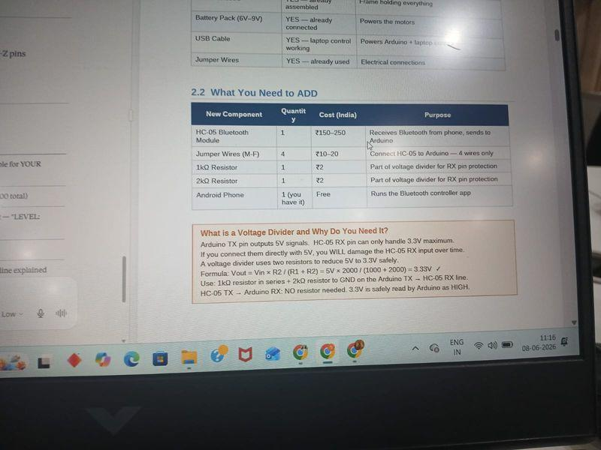
Fig 9 — Your car during Bluetooth testing session with HC-05 module connected

Important Before Running
Arduino Serial Monitor must be CLOSED. They cannot share the port.
HC-05 must be paired to Windows (Settings -> Bluetooth -> HC-05 -> Pair)
Find your BT COM port: Device Manager -> Ports -> Standard Serial over Bluetooth
Your actual ports from Device Manager: COM3, COM4, COM7, COM8
Try COM7 first. If error, try COM8, then COM4, then COM3.
HC-05 "Not connected" in Windows Bluetooth settings is NORMAL — Python connects it.

rc_car_bt.py | Python 3 | Bluetooth control | Change COM_PORT to your HC-05 BT port
# ================================================================
# RC CAR — PYTHON CONTROLLER (BLUETOOTH MODE)
# Use this when HC-05 is connected to Windows Bluetooth
# Install: pip install pyserial keyboard
# Change COM_PORT to your HC-05 Bluetooth COM port (e.g. COM7)
# HOW TO FIND YOUR BT PORT:
# Device Manager > Ports (COM & LPT) > Standard Serial over
# Bluetooth link — note the COM number (usually higher: COM7/COM8)
# ================================================================
import serial, keyboard, time, sys

COM_PORT = "COM7" # HC-05 Bluetooth COM port (NOT Arduino USB port)
BAUD_RATE = 9600

print("Connecting to HC-05 Bluetooth on " + COM_PORT + "...")
print("Make sure: 1) HC-05 LED is blinking")
print(" 2) Serial Monitor is CLOSED")
print(" 3) HC-05 is paired in Windows Bluetooth\n")
try:
arduino = serial.Serial(COM_PORT, BAUD_RATE, timeout=0.1)
time.sleep(2)
print("Bluetooth Connected!\n")
except:
print("ERROR: Cannot connect to " + COM_PORT)
print("Fixes to try:")
print(" 1. Close Arduino Serial Monitor completely")
print(" 2. Try COM8 instead of COM7")
print(" 3. Try COM4 or COM3")
print(" 4. Check HC-05 LED is blinking (has power)")
print(" 5. Pair HC-05 in Windows Bluetooth settings first")
sys.exit(1)

print("=== RC CAR BLUETOOTH CONTROLLER ===")
print("Arrow Keys = Drive SPACE = Stop ESC = Quit")
print("1=Slow 2=Medium 3=Fast")
print("G=RotateLeft I=RotateRight")
print("NOTE: Close this script before using phone app\n")

last_cmd=''; last_speed='3'
NAMES={'F':'FORWARD','B':'BACKWARD','L':'TURN LEFT','R':'TURN RIGHT',
'S':'STOP','G':'ROTATE LEFT','I':'ROTATE RIGHT',
'1':'SPEED: SLOW','2':'SPEED: MEDIUM','3':'SPEED: FAST'}

def send(cmd):
global last_cmd
if cmd!=last_cmd:
arduino.write(cmd.encode())
last_cmd=cmd
print(">> "+NAMES.get(cmd,cmd))

def send_speed(lvl):
global last_speed,last_cmd
if lvl!=last_speed:
arduino.write(lvl.encode())
last_speed=lvl; last_cmd=''
print(">> "+NAMES.get(lvl,lvl))

try:
while True:
if keyboard.is_pressed('1'): send_speed('1')
elif keyboard.is_pressed('2'): send_speed('2')
elif keyboard.is_pressed('3'): send_speed('3')
if keyboard.is_pressed('up'): send('F')
elif keyboard.is_pressed('down'): send('B')
elif keyboard.is_pressed('left'): send('L')
elif keyboard.is_pressed('right'): send('R')
elif keyboard.is_pressed('space'): send('S')
elif keyboard.is_pressed('g'): send('G')
elif keyboard.is_pressed('i'): send('I')
elif keyboard.is_pressed('esc'): break
else: send('S')
time.sleep(0.08)
except Exception as e:
print("Error: "+str(e))

arduino.write(b'S'); arduino.close()
print("\nCar stopped. Bye!")

8.1 USB vs Bluetooth Python — Key Differences
Item | USB Script (rc_car_usb.py) | Bluetooth Script (rc_car_bt.py)
COM_PORT value | Your Arduino USB port e.g. COM5 | Your HC-05 BT port e.g. COM7
Arduino code needed | rc_car_normal.ino | rc_car_bluetooth.ino
Serial Monitor | Can open for debugging | MUST BE CLOSED
HC-05 module needed | No | Yes, wired and paired
Error message | ERROR: Cannot connect to COM5 | ERROR: Cannot connect to COM7
What to do if error | Check COM port in Arduino IDE | Check HC-05 LED, check pairing
Phone control works | No | Yes (close Python first)

Section 9 — All Problems Encountered: From Beginning to End
Every single problem that occurred during your actual build and Bluetooth setup session, with the exact cause and fix. These are real problems from your real build, not hypothetical ones.

9.1 Hardware Problems — Build Phase

PROBLEM: Motors not moving at all — car completely dead
Cause: ENA/ENB jumper caps missing on L298N. OR Arduino GND not connected to L298N GND.
Fix: Add jumper caps on ENA and ENB pins. AND connect black wire from Arduino GND to L298N GND. This is the most common beginner problem.

PROBLEM: One motor spinning in wrong direction
Cause: That motor wires are connected with reversed polarity at L298N OUT terminals.
Fix: Swap the two wires of that motor: left motor wrong = swap OUT1 and OUT2. Right motor wrong = swap OUT3 and OUT4.

PROBLEM: Car drifts left or right instead of going straight
Cause: Budget DC motors have manufacturing tolerances — same code produces slightly different speeds.
Fix: Lower L_SPEED by 5 if car drifts right. Lower R_SPEED by 5 if car drifts left. Re-upload and test. Repeat until straight.

PROBLEM: HC-05 GND wire missing — your actual build issue
Cause: In your build photos (Image 5 from session), HC-05 had only 3 wires: red, yellow, white. The black GND wire was missing.
Fix: Add a black wire from HC-05 GND pin to Arduino GND pin. This was the root cause of HC-05 not powering on.

9.2 Software Problems — Upload Phase

PROBLEM: No COM port visible in Arduino IDE
Cause: CH340 USB-to-serial driver not installed on laptop. OR charge-only USB cable with no data lines.
Fix: Search CH340 driver download and install. Try different USB cable. Try different USB port on laptop.

PROBLEM: Serial Monitor shows garbled characters or symbols
Cause: Baud rate mismatch: Arduino code uses Serial.begin(9600) but Serial Monitor dropdown is set to different value.
Fix: Set Serial Monitor baud rate dropdown to 9600. Must match Serial.begin(9600) in Arduino code exactly.

PROBLEM: Done uploading but car does not respond to Serial Monitor
Cause: Wrong COM port selected. Or Serial Monitor baud rate wrong.
Fix: Verify COM port in Tools > Port. Check baud rate is 9600. Unplug and replug Arduino, then re-select port.

9.3 Bluetooth Connection Problems — Your Actual Issues

PROBLEM: HC-05 not visible when scanning from phone or laptop
Cause: HC-05 had no power because GND wire was missing. Without GND, module does not boot and is not discoverable.
Fix: Add GND wire (black) from HC-05 GND to Arduino GND. Power Arduino via USB. HC-05 LED must blink fast.

PROBLEM: ERROR: Cannot connect to COM7 in Python
Cause: Confirmed from your VS Code screenshot. HC-05 was not connected to Windows at that moment.
Fix: HC-05 "Not connected" in Windows Bluetooth is normal. Just run Python script — it connects automatically through COM7. If still failing, close Arduino Serial Monitor first.

PROBLEM: Serial Monitor was blocking Bluetooth — your actual issue
Cause: From your screenshot: Arduino Serial Monitor was open showing FORWARD BACKWARD etc. This holds the COM port exclusively.
Fix: Close Serial Monitor completely (click X on that tab). Only then run Python Bluetooth script. They cannot share the port.

PROBLEM: HC-05 shows Not connected in Windows Bluetooth settings
Cause: This confused you during the session. Windows Bluetooth shows Not connected for serial modules because they are not audio/headset devices.
Fix: This is completely NORMAL for HC-05. Do NOT click Connect in Windows Bluetooth. Just run the Python BT script. It will connect automatically.

PROBLEM: Python ERROR: Cannot connect to COM7 even after closing Serial Monitor
Cause: COM7 only appears in Device Manager when HC-05 is actively paired and powered. If HC-05 LED is off, COM7 disappears.
Fix: Check HC-05 LED blinks. If no LED: fix GND wire. Then go Windows Bluetooth > HC-05 > Remove > Re-pair. Then run Python.

PROBLEM: HC-05 showing Connecting in Windows (Image 1 of your session)
Cause: Windows was actively trying to connect HC-05 but timing out. Module was powered but GND issue caused unreliable connection.
Fix: Fix the GND wire. Remove HC-05 from Windows Bluetooth paired devices. Re-pair fresh. Enter PIN 1234.

PROBLEM: Mobile phone app cannot connect to HC-05
Cause: Python BT script was running on laptop, holding the COM7 port. Only one device can connect to HC-05 at a time.
Fix: Close the Python BT script completely first (press ESC). Then open phone Bluetooth app and connect to HC-05.

PROBLEM: Device Manager showed COM3 COM4 COM7 COM8 — which one to use
Cause: Your Device Manager showed 4 Standard Serial over Bluetooth link entries. Not clear which belongs to HC-05.
Fix: Try COM7 first (higher number = outgoing BT port in Windows). If error, try COM8, COM4, COM3. Change COM_PORT in Python script.

PROBLEM: AmpersandNotAllowed error in VS Code terminal
Cause: From your VS Code screenshot: PowerShell was treating the & in the run command as a special character.
Fix: Run script directly: python rc_car_manual.py (not using & in the command). Or use VS Code Run Python File button.

9.4 Mobile App Problems

PROBLEM: Cannot find a suitable app for HC-05 control
Cause: Several apps exist but not all work with HC-05 SPP (Serial Port Profile).
Fix: Install Serial Bluetooth Terminal by Kai Morich from Play Store. Type F and Send to test. If that works, install Arduino Bluetooth Controller by Giumig Apps for button control.

PROBLEM: App shows connected but car does not respond
Cause: App may be sending different characters. Some apps send newline or carriage return after the character.
Fix: Use Serial Bluetooth Terminal first — type exactly F and send. Check if Serial Monitor shows FORWARD. If yes, BT works. Problem is app button configuration.

Section 10 — Testing Procedure

10.1 Normal USB Mode Test
- Upload rc_car_normal.ino to Arduino. Open Serial Monitor at 9600 baud.
- Verify RC CAR NORMAL MODE banner appears in Serial Monitor.
- Type F press Enter. Car should move forward. Type S to stop.
- Test B L R G I one by one. Verify Serial Monitor shows each command.
- Close Serial Monitor. Run: python rc_car_usb.py
- Hold UP arrow. Car moves forward. Release. Car stops.
- Test all arrow keys. Press 1 2 3 to verify speed changes.

10.2 Bluetooth Mode Test
- Wire HC-05 to Arduino: +5V Red, GND Black, TX to Pin10 Green, RX from Pin11 Yellow.
- CHECK: HC-05 LED blinks fast after powering Arduino via USB.
- Upload rc_car_bluetooth.ino to Arduino.
- Open Serial Monitor. Verify BLUETOOTH + LAPTOP MODE appears.
- CLOSE Serial Monitor completely.
- Windows Settings > Bluetooth > scan > click HC-05 > PIN 1234 > Pair.
- Device Manager > Ports > note the Standard Serial over Bluetooth COM number.
- Edit rc_car_bt.py: change COM_PORT to that number (e.g. COM7).
- Run: python rc_car_bt.py
- Verify terminal shows Bluetooth Connected!
- Hold UP arrow. Car moves. Release. Car stops. Bluetooth is working.
- For phone: close Python script. Open Serial Bluetooth Terminal. Connect HC-05. Type F. Car moves.

Section 11 — Android Phone Control Setup
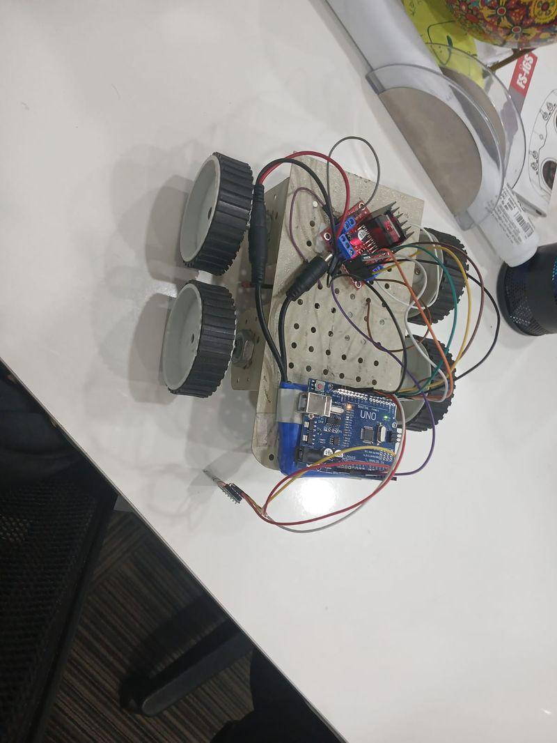  Fig 10 — HC-05 module powered on with red LED visible | 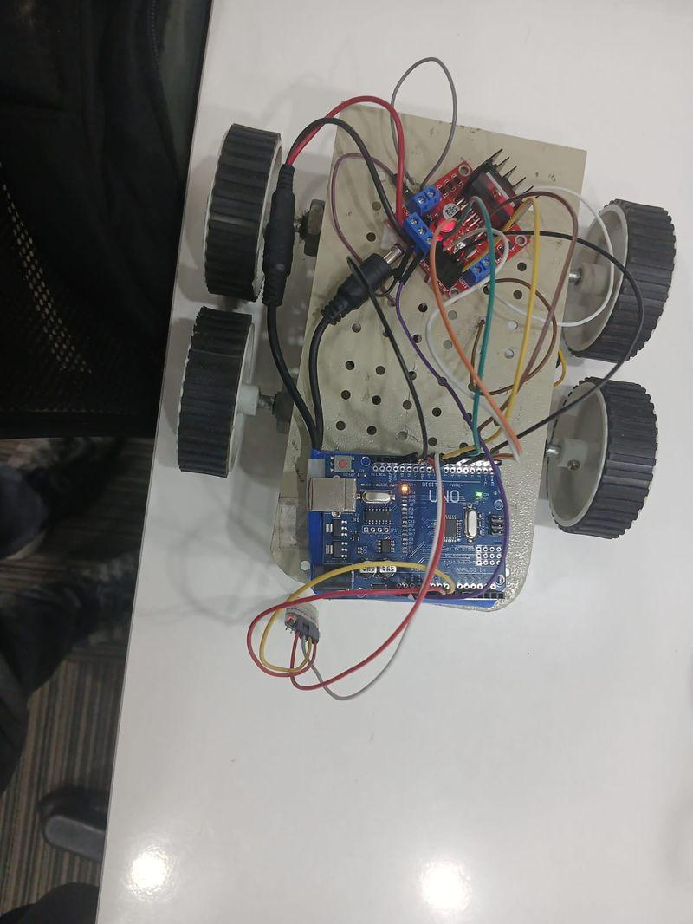  Fig 11 — HC-05 connected with wires to Arduino

11.1 Recommended Apps
App Name | By | Purpose | Best For
Serial Bluetooth Terminal | Kai Morich | Type commands manually, best for testing | First test to verify BT works
Arduino Bluetooth Controller | Giumig Apps | Customizable buttons, assign F B L R S G I | Daily driving with buttons
Bluetooth RC Controller | Various | Joystick style control | Fun joystick driving

11.2 Pairing Steps
- Power on Arduino via USB. HC-05 LED must blink fast.
- Close any Python BT script that may be running.
- Android Settings > Bluetooth > turn ON.
- Tap Scan or Add new device.
- Find HC-05 in the list. Tap it.
- Enter PIN: 1234. Tap Pair.
- HC-05 LED now blinks slowly = paired.
- Open Serial Bluetooth Terminal app.
- Tap the plug icon > select HC-05 > Connect.
- LED blinks very slow or stays on = connected.
- Type F in terminal and tap Send. Car should move forward.
- Type S to stop.

Important Rule: One Device at a Time
HC-05 can only talk to ONE device at a time.
If Python BT script is running on laptop: phone CANNOT connect.
If phone app is connected: Python BT script CANNOT connect.
To switch: close one, then open the other.
Arduino Serial Monitor must be closed when either phone or Python BT is in use.

Section 12 — Future Upgrade Roadmap
Stage | Upgrade | New Hardware | Difficulty | Benefit
Stage 1 | USB Laptop Control | None — already done | DONE | Arrow keys, speed control
Stage 2 | Bluetooth HC-05 | HC-05 module Rs 200 | DONE | Phone + laptop control
Stage 3 | Obstacle Avoidance | HC-SR04 sensor Rs 80 | Medium 3/5 | Auto stop at walls
Stage 4 | Line Following | 2x TCRT5000 Rs 60 | Hard 4/5 | Fully autonomous
Stage 5 | WiFi Control | NodeMCU ESP8266 Rs 300 | Hard 4/5 | Browser control
Stage 6 | AI Robot | Raspberry Pi + Camera | Advanced 5/5 | Object detection

Your Immediate Next Step
You are currently at Stage 2 — Bluetooth HC-05.
Fix: Add GND wire to HC-05 if not done yet.
Fix: Upload rc_car_bluetooth.ino.
Fix: Change COM_PORT to COM7 in rc_car_bt.py.
Fix: Close Serial Monitor, run Python BT script.
After BT works: Stage 3 — add HC-SR04 ultrasonic sensor for obstacle avoidance.

